Date last modified/updated: Click here to enter a date. Internal audit: Click here to enter a date.

Who last modified/updated: Click here to enter text. Management review: Click here to enter a date.

This part of the Navigator Playbook is completed when you have:
Considered the strategic issues and requirements identified as part of Task 1 (An EnMS and Your Organization) and determined the scope and boundaries of the energy management system (EnMS).
Developed an EnMS Scope and Boundaries Statement.

- Determine Scope and Boundaries
☒ We considered the strategic issues and requirements identified in Task 1 (An EnMS and Your Organization) before determining our scope and boundaries.
☒ Identified the extent of activities, facilities, and decision structures to be included in your EnMS
Detail here:
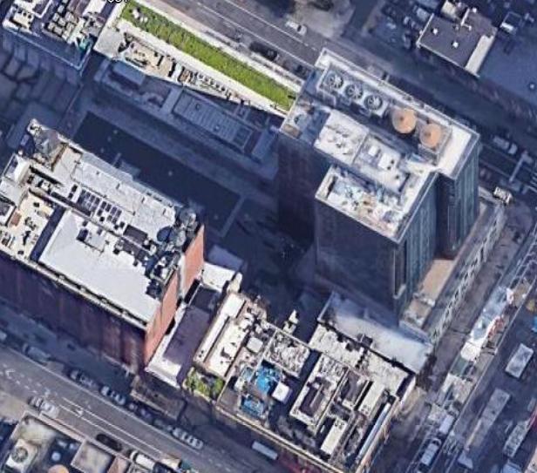
This hotel is in the downtown area and consists of 400 guestrooms. The hotel is part of a master development including condominiums on the upper floors as well as an adjoining office tower, parking garage, and several small businesses and restaurants. The entire property layout covers one city block. The hotel boundary is within the main tower and includes basement level through the 18th floor of a 28-story building. A full-service restaurant and bar are located on the lobby level, and the hotel includes over 40,000 sq. ft of meeting space, including a large kitchen space with fully functional walk-in coolers and additional refrigeration. There is a spa and gym accessible to hotel guests. However, this operation is managed separately from the hotel.

☒ Defined site limits and/or organizational limits of your EnMS
Detail here:
The only entity or area not included in our EnMS would be the spa and gym. While they are located on the property, they are sub metered, separately billed, and have their own infrastructure.

- Develop an EnMS Scope and Boundaries Statement
Detail here:
Sustainability and a detailed energy management system are necessary today to be a responsible business, to remain competitive, to follow current legislation, and to follow the corporate policy. Our objective is to continue our responsible business policy regarding sustainability and “green” practices. We will improve upon it as we understand and analyze our energy usage through our EnMS.
We will use our current initiatives and equipment to measure energy usage to be able to set goals and improve our practices. We will use our Green Team and energy meetings to monitor the milestones of progress of the project. We will look for ways to accomplish and supersede our goals while being mindful of the budgetary limitations and making certain to avoid a negative impact on the guest experience.
The hotel is managed by the corporate team under the supervision of the General Manager. The scope and boundaries for this EnMS include the hotel operations for 400 guestrooms, a full-service restaurant and bar, meeting and event spaces along with service from a large kitchen space. The spa and gym are located within this property but are excluded from the scope of this EnMS.

Top Management Approval
☐ | Date approved: | Click here to enter a date.
☐ | Who approved: | Click here to enter text.

Comments
Click here to enter text.

